The Cost of Smoking

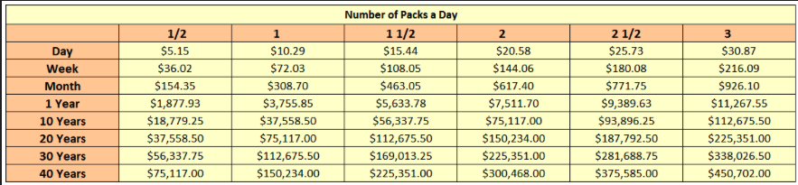

6 Ways to Save on Chantix and Quit Smoking

written by Tori Marsh, MPH
Updated on September 7, 2022
Key takeaways:
- Chantix is a popular, and pricy, medication that helps people stop smoking.
- Find out how to get Chantix for free with a patient assistance program if you qualify.
- A generic Chantix is available, which could help you save money.

Pay $ 192.25 at Walgreens with a GoodRx discount. That's 44% off the retail price of $346.
Walgreens
$346retail
Save 44%
$192.25

Pay $ 340.29 at Walmart with a GoodRx discount. That's 30% off the retail price of $487.
Walmart
$487retail
Save 30%
$340.29

Pay $ 267.69 at CVS Pharmacy with a GoodRx discount. That's 21% off the retail price of $340.
CVS Pharmacy
$340retail
Save 21%
$267.69

Emerging in 2006, Chantix quickly became known as one of the best ways to quit smoking. But, as a brand-only drug, Chantix was quite pricey — a month’s supply cost over $500. However, in 2021 a generic version of Chantix launched. You still need a prescription to get Chantix, but there are now several ways to save on the medication. You may even be able to get free.

What is Chantix?
Chantix is a popular, but expensive, prescription drug used for smoking cessation. Research shows that the medication helps people stop smoking, particularly if patients also enroll in counseling and support programs.
Keep in mind that Chantix can have some serious side effects like nightmares, suicidal thoughts and amnesia. In fact, these side effects were so severe that Chantix once had a black-box warning, the most severe kind of warning possible for a drug. In 2009, the FDA allowed Pfizer to remove the warning, believing that the benefits of Chantix outweighed its risks. Be sure to speak with your healthcare provider before taking Chantix or if you experience any of these side effects.
In 2021, Pfizer issued a voluntary recall of Chantix because the drug had high levels of nitrosamines, or possible cancer-causing agents. The drug is still available and being made with acceptable levels.

How much does Chantix cost?
Chantix is not cheap. In fact, a 2018 GoodRx analysis found that monthly prices for Chantix increased by more than 106% over the previous five years. The average retail price as of July 2022 was about $555 for the most common version.
To help people save money, generic Chantix is now on the market.

Is generic Chantix available?
In 2021, the FDA approved the first generic version of Chantix, called varenicline. It is developed by Par Pharmaceutical, which is part of Endo International. It is available in 0.5 mg and 1 mg doses. The lowest GoodRx price for fifty-six 1 mg tablets of varenicline is about $192.

Savings Tip #1: Use your insurance, or ask your provider to submit an appeal
The best way to save on Chantix is to use your insurance if you have it. According to MMIT’sdrug formulary database, Chantix is covered by most commercial insurance plans. Unfortunately, Chantix is considered a tier 3 drug on many of these formularies, meaning that many patients will have to pay high out-of-pocket costs.
If Chantix is no longer covered by your insurance plan, ask your healthcare provider about submitting an appeal. The exact process will depend on your insurer, but often requires that you work with your provider to submit an appeal letter.

Savings Tip #2: Save as much as $75 per month with a savings card
Manufacturer Pfizer offers a free savings card to help reduce out-of-pocket costs to as little as $40 per fill.
Program website | www.chantix.com/support-for-taking-chantix/chantix-savings
Phone number | 1-800-746-4678
Manufacturer | Pfizer
How much can I save? | You can save up to $175 per use or the amount of your copay, whichever is less. The card cannot be used more than 6 times within the calendar year. The maximum savings per year is $1,050.
How do I get the discount? | Download and print your card. Bring it with you to the pharmacy when you pick up your prescription.
Are there any restrictions? | This card is for both insured and uninsured individuals. Keep in mind that you will pay more without commercial insurance. People with Medicare, Medicaid, Tricare, or other government insurance are not eligible.
While this is a good option, especially for those who pay high out-of-pocket costs for Chantix, there is debate surrounding the long-term effects of copay cards. Critics of these cards claim that they drive insurance premiums up, mask manufacturer price hikes, and discourage the use of cost-effective generics.

Savings Tip #3: Get Chantix for free through a patient assistance program
Uninsured, low income patients may be able to get Chantix for free with the Pfizer Patient Assistance Program (PAP).
Program website | https://www.pfizerrxpathways.com/
Phone number | 1-866-706-2400
Manufacturer | Pfizer
How much can I save? | Your prescription may be free if you qualify.
How do I get the discount? | Download and fill out your part of the application. Then, ask your doctor to help you submit it.
Are there any restrictions? | You will need a valid prescription and proof of your gross monthly household income. Contact the program to see if you are eligible for free Chantix.

Savings Tip #4: Speak to your provider about prescription workarounds
If the above options don’t work for you, speak with your healthcare provider about other ways to save. Your provider may talk to you about getting a prescription for a higher-dose pill (which you can cut in half to save on cost), filling a 90-day supply (which can be cheaper than a 30-day supply) or getting free samples.

Savings Tip #5: Ask about generic Chantix
Generic Chantix, which is known as varenicline, can help you save money as well. Ask your healthcare provider if trying varenicline may be right for you.

Savings Tip #6: Ask your provider about Chantix alternatives
While Chantix is one of the few prescription medications available specifically to help you quit smoking, there are other treatment options available. If you think a prescription-strength medication is best for you, consider speaking with your healthcare provider about Zyban, an antidepressant that can also help control nicotine cravings.
In addition to the prescription-strength medications, people have seen success with over-the-counter products like nicotine patches or gum, and other ways to quit smoking.

The bottom line
Chantix is a popular, and pricey, medication that helps people stop smoking. You may be able to save money on Chantix by using generic Chantix or trying drug manufacturer savings programs.

